SIMATS ENGINEERING
ASSESSMENT TOOL 2
COURSE NAME: Fundamentals Of Data Science COURSE CODE: DSA04
COURSE OUTCOME COVERED
CO3: Evaluate datasets using descriptive statistics, including summarization, outlier detection, and distribution analysis, and perform statistical inference through estimation and hypothesis testing. (BL3)
Assessment Tool Weightage: 20%
QUESTIONS: 02 Total Marks:100 Annexure A
Data Interpretation
Code of Conduct:
I Anto Chriswin G / 192324093 (Name / Reg No) certify that this submission is my original work and that I have adhered to the guidelines specified for this assessment.
I understand that any violation of academic integrity rules will result in disciplinary action.
Signature of the student:
RUBRICS FOR CALCULATION
Criteria | Weightage | Level  4 (Exemplary)  5 Marks | Level  3 (Proficient)  3 /4 Marks | Level  2 (Developing)  2 Marks | Level  1 (Beginning)  1 Mark | Marks
Understanding of Data | 25% | Accurately interprets all data patterns, trends, and relationships | Interprets data  correctly with  minor gaps | Partial  understanding;  misses key trends | Misinterprets or fails to  understand data
Analysis | 25% | Provides deep analysis with strong logical  reasoning and  justification | Provides  reasonable  analysis with some justification | Basic analysis  with weak  reasoning | No meaningful analysis  provided
Application of Concepts | 20% | Effectively applies  relevant concepts/tools to interpret data accurately | Applies concepts with minor errors | Limited  application;  requires guidance | Unable to apply concepts to data
Conclusion | 20% | Draws clear, meaningful conclusions with strong insights and implications | Provides valid  conclusions with moderate insights | Conclusions are  vague or weak | No clear or  valid  conclusions
Clarity | 10% | Presents interpretation clearly using proper  structure, visuals, and terminology | Generally clear  with minor issues | Lacks clarity or  proper structure | Poor  presentation and difficult to  understand

Annexure A
Problem 01: Hospital Patient Health Monitoring
Scenario
A hospital wants to investigate how patient lifestyle factors affect blood pressure levels. Dataset
Patient_ID | Daily_Exercise (Minutes) | BMI | Systolic_BP
P001 | 10 | 32 | 150
P002 | 15 | 31 | 148
P003 | 20 | 30 | 145
P004 | 25 | 29 | 142
P005 | 30 | 28 | 138
P006 | 35 | 27 | 134
P007 | 40 | 26 | 130
P008 | 45 | 25 | 126
P009 | 50 | 24 | 122
P010 | 55 | 23 | 118

Tasks
1. Find the mean and standard deviation of blood pressure.
2. Calculate covariance between:
o Exercise and Blood Pressure
o BMI and Blood Pressure
3. Calculate correlation coefficients.
4. Identify whether exercise or BMI is more strongly associated with blood pressure.
5. Discuss possible healthcare interventions.

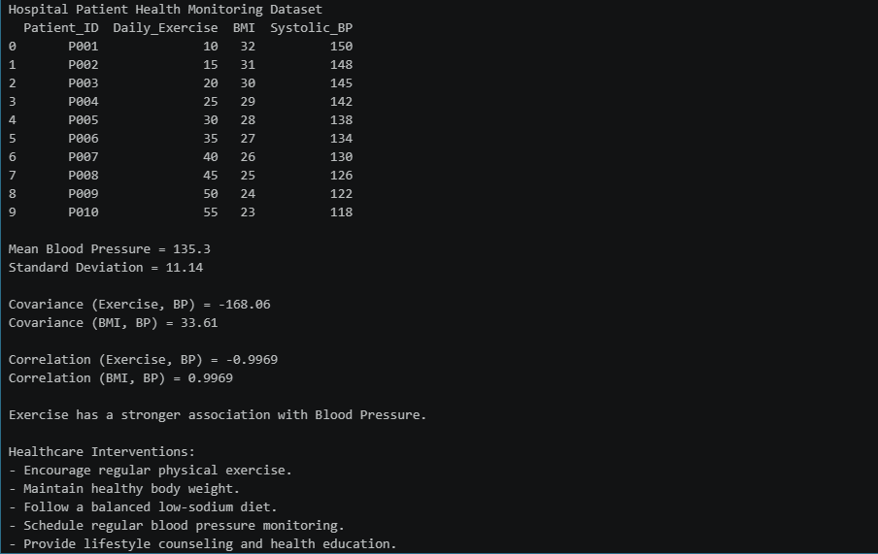

Problem 02: E-Commerce Customer Behaviour Analysis
Scenario
An e-commerce company wants to identify factors influencing customer spending. Dataset
Customer_ID | Website_Visits | Time_Spent (Minutes) | Purchase_Amount (₹)
C001 | 5 | 20 | 1200
C002 | 8 | 25 | 1800
C003 | 10 | 30 | 2500
C004 | 12 | 35 | 3200
C005 | 15 | 40 | 4000
C006 | 18 | 45 | 5000
C007 | 20 | 50 | 6200

C008 | 23 | 55 | 7300
C009 | 25 | 60 | 8500
C010 | 28 | 70 | 10000

Tasks
1. Calculate mean, variance, and standard deviation of Purchase Amount. 2. Find covariance between:
o Website Visits and Purchase Amount
o Time Spent and Purchase Amount
3. Calculate correlation coefficients.
4. Determine which customer behavior metric better predicts spending. 5. Suggest marketing strategies based on the findings.

